

STATE OF ILLINOIS JUSTICE INFORMATION NETWORKS

The State of Illinois currently operates two statewide network services, the Illinois Century Network and the Illinois Frame Relay Service. Either network has the capability to handle all justice information traffic in Illinois. As bandwidth needs expand, both networks can easily add capacity. (Bandwidth, the width of a band of electromagnetic frequencies, determines how fast data flows on a given transmission path.)

The Illinois Central Management Services (CMS) Frame Relay Network

At present, the CMS Frame Relay Network is used by most Illinois law enforcement agencies to access the State’s criminal history and offender status system, LEADS. Since these agencies already have a Frame Relay connection, this network could be used for access to other justice information services when they are made available. A separate Permanent Virtual Connection (PVC) may be required to access other services, but the cost of a PVC is quite low when compared to the cost of establishing a completely new circuit.

According to CMS literature, the Frame Relay System is a low to medium speed packet data communications service. It is a connection-oriented data service that relays variable length frames (packets) across Permanent Virtual Connections (PVCs). PVCs are end-to-end, bi-directional logical channels that move data from one port to another port. A Committed Information Rate (CIR) is programmed for each PVC, but packets in excess of the CIR will be carried across the network so long as no network congestion is encountered. This means that under normal operating circumstances, users of the network will enjoy delivery rates in excess of the CIR.

There is a range of service offerings available to agencies depending on the need for data throughput. The data transmission rates offered vary from 9.6 kilobits per second (kbps) to 20.07 megabits per second (Mbps, also known as millions of bits per second). This range of speeds should suffice for almost all justice communications needs, from the smallest to the largest.

These CMS Frame Relay offerings are broken down into three categories as follows:

DS0 (56/64 kbps)

- Maximum of 30 Data Link Connection Identifiers (DLCI)
- Oversubscription is allowed on up to 200% of access circuit speed.
- Hardware is provided by CMS.
- Available PVCs are 9.6 kbps, 19.2 kbps, 32 kbps, 56 kbps, 64 kbps.

DS-1 (1.544 mbps)
- Maximum of 928 Data Link Connection Identifiers (DLCI).
- Oversubscription is allowed up to 200% of access circuit speed
- Available PVCs are 9.6 kbps, 19.2 kbps, 32 kbps, 56 kbps, 64 kbps, 128 kbps, 256 kbps, 384 kbps, 768 kbps, and 1.544 kbps.

DS-3 (45 mbps)
- Maximum of 938 Data Link Connection Identifiers (DLCI).
- Oversubscription is allowed up to 200% of access circuit speed.
- Available PVCs are 9.6 kbps, 19.2 kbps, 32 kbps, 56 kbps, 64 kbps, 128 kbps, 256 kbps, 384 kbps, 768 kbps, 1.544 kbps, 3.09 mbps, 4.63 mbps, 6.18 mbps, 7.72 mbps, 9.26 mbps, 10.81 mbps, 12.35 mbps, 13.90 mbps, 15.44 mbps, 16.98 mbps, 18.53 mbps, and 20.07 mbps.

To put the above-listed connection speeds into perspective, it should be noted that the maximum connection speed for a dial-up Internet connection is presently 56.6 kbps. However, the lowest speed offered by CMS, 9.6 kbps, is suitable for multiple users when only screen and keyboard attributes are transmitted (“dumb terminal” connections to a mainframe). It may also be suitable for smaller groups using more data intensive and graphically rich applications. At the top end, the 20.07 mbps speed offered by CMS probably exceeds the data communications needs of most applications and will likely be adequate for almost any imaginable state or local agency data communications need (at the time of this writing). Because CMS allows users to exceed their allotted CIR unless the Frame Relay Network is congested, the lowest level of service may be entirely adequate for most applications.
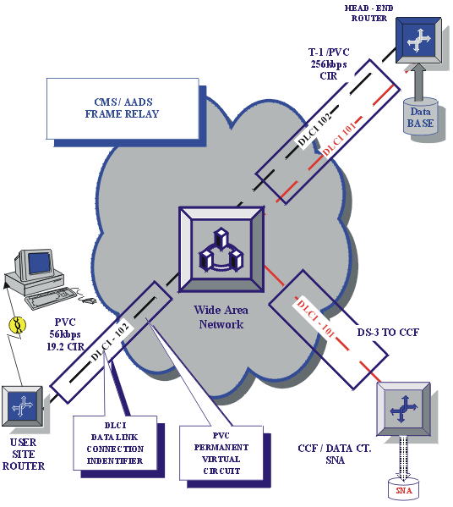
The cost of a new Frame Relay installation is $1,341.20 for the installation of hardware and a T1 circuit. The recurring monthly cost is $1,027.70 for a 19.2 PVC (the most commonly requested speed. The cost of additional PVCs is $71.20 for the circuit and additional monthly charge depending on the circuit bandwidth as follows: $17.20 for a 19.2 kbps PVC; $33.70 for a 128 kbps PVC; and $50.60 for a 256 kbps PVC.

All required hardware, which includes a CSU/DSU unit and a Cisco router, is factored into the one-time installation charge. All local loop charges are covered by CMS.

The Illinois Century Network (ICN)

The Illinois Century Network was established by the Illinois General Assembly on July 1, 1999 to provide communications services to Illinois schools, institutions of higher learning, libraries, museums, research institutions, state agencies, units of local government and other local entities that provide services to Illinois citizens. Its original purpose was to “be capable of delivering state-of-the-art access to education, training, and electronic information and shall provide access to networking technologies for institutions located in even the most remote areas of this State.”

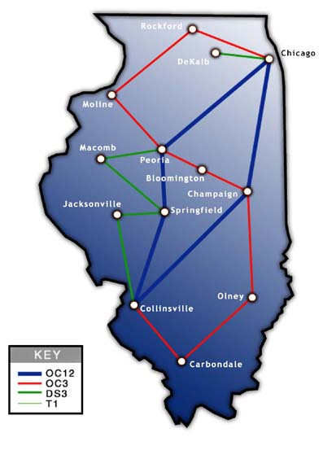
Presently, the ICN is a telecommunications backbone that provides high-speed access to many public institutions, at both the state and local level. Up to a pre-determined amount of use, Internet access through this network is available at no cost to eligible subscribers but the customer may bear the cost of equipment at the subscriber’s site (Customer Premise Equipment) and the cost of getting access to an ICN Point of Presence (POP). Access to the POP takes place through private leased lines, which are available from local telephone companies.

The ICN network currently has 17 POPs located throughout the State. Although subscribers must bear the cost of data communications from their site to the closest POP, the ICN actively negotiates with local telecommunications providers to ensure that subscribers pay the lowest possible rates to reach the ICN. Even so, an agency located at a substantial distance from a POP could pay substantial fees to their local telephone company to reach the closest ICN POP. Once connected to the ICN, agencies can either use the network for Internet access or can only use the network to reach other ICN subscriber agencies.

Data security is the responsibility of the using agency. Due to the shared nature of the network, data packets could theoretically be intercepted by those having access to the ICN network. Therefore, in order to satisfy national requirements for transfer of criminal history information over public networks, the information would have to be encrypted at a 128 bit encryption level.

The total cost of establishing an ICN connection varies considerably due to differing costs of leasing a line from the local communications company to the closest ICN POP. The ICN also charges nominal fees for municipal agencies to subscribe to ICN services. Prices begin at $38.75 per month for a 56K connection and go up to $525 per month for an unrestricted T1 connection. Rates are also available for cable, DSL, direct Ethernet connections and other types of connections, which are calculated at $300 per month per Mbps (mega bits per second or million bits per second). Local leased circuit charges (local loop) will vary depending on location.

Summary

Both the CMS Frame Relay Network and the ICN network can be used by State and local agencies for justice purposes. The choice of which network to use will probably be dictated by price. The ICN may be the best choice for those agencies that are close to the ICN POP; however, those agencies that are distant from a POP may have to endure hefty fees charged by their local telecom providers to get to the network POP.

In terms of price, the Frame Relay network may be the best choice for those agencies that have existing connections to the network. Many times, these agencies will only have to pay for additional PVCs to make an additional Frame Relay connection. The ICN may be the best choice for agencies not having an existing frame relay connection; however, each communications situation is different so agencies should compare prices offered by the ICN and CMS. The unique circumstances of each communications need will determine which supplier is the better choice.

