Summary This document presents a plan to develop integrated justice in Illinois. It addresses the strategic issues that have been identified as being crucial to criminal justice information sharing and recommends the establishment of a justice portal to fulfill these requirements.

Background Recognizing the need to share critical information, the State of
Illinois established the Illinois Integrated Justice Information System (IIJIS) Board in 2001. This board, comprised of representatives from state, county, and municipal justice agencies, was charged with the responsibility of developing a plan for justice information sharing in Illinois. Their report, the Illinois Integrated Justice Information System Strategic Plan was completed in December 2002. In order to implement the strategic plan developed by the IIJIS Board, the State of Illinois created the Illinois Integrated Justice Information System Implementation Board in 2003. (The work of the original IIJIS Board ended upon the submission of the strategic plan.)

Strategic Plan The strategic plan was created to provide a foundation for future
projects aimed at automating criminal justice information sharing. It was developed using the strategic planning process adopted by the State of Illinois. Strategic planning is a way of answering the question: “Where should we be going and how will we get there?” The desired future state of justice integration (where we want to be) was determined by the Scenario for Information Sharing in Illinois. An inventory of the existing components of the Illinois justice system was also conducted in order to document the gaps between the desired state of integration, as set forth in the scenario, and current information sharing practices in Illinois.

Current State The following state justice systems have been identified as having
a direct impact on integrated justice. The telecommunication networks listed have the capacity to transport justice information throughout the state.
• Automated Victim Notification (AVN) System
• Criminal History Record Information (CHRI)
• IDOC Offender Management Systems
• Law Enforcement Agencies Data System (LEADS)
• POLARIS
• Secretary of State Data Systems
- CMS Frame Relay Network & the Illinois Century Network
Gap Analysis Current technology was validated against the scenario to identify
the gaps, which exist today. The information collected identified the following information needs:

Police
- Probation status information and probation and parole conditions
- Digital photos
- Current bond information
- An improved format for officer safety information communicated to in-car mobile data computers.

Circuit Court Clerks
- The ability to accept charging documents electronically from prosecutors and police.
- The ability to transmit hearing dates and court generated documents electronically to other justice agencies in order to facilitate workflow or place court decision data in the hands of decision-makers more quickly.

Findings The scenario and gap analysis suggest that two areas of concentration are needed for integrated justice in Illinois:
- Improved access to and enhanced state level systems
- The development of county level justice integration systems

The following are integration projects that would close the gaps identified in the Scenario and enhance integrated justice in Illinois:

Improved State Levels Systems
- Probation Status and Probation and Parole Conditions
- Digital Mug Shots
- Inmate Locator
- Bond Information and Conditions
- Juvenile Arrest and Station Adjustment Information
- Local Jail Bookings
- Web based CHRI

County/Local Level Systems
- County Justice Hub
  - Transfer Information to State Agencies
  - Facilitate County-Level Integrated Justice
- Standard Police Incident Report
- Standard Police Arrest Report
- Standard Prosecutors Case Management System
      - Standard Jail Management System
      - Standard Court Management System
Illinois Justice Network The proposed Illinois Justice Network would be a hybrid system that provides information obtained directly from state supported systems, through a justice portal; from local agencies through a county hub application; and from a central data warehouse.


Portals are tools for accessing and organizing information through the Internet or private Intranet, similar to a Web site. Portals provide a single point of contact for access to diverse applications and information throughout the justice enterprise. The portal allows agencies with different computer platforms and information needs to jointly develop a system that benefits them all, without compromising an agency’s security or data management requirements.

Portal It is envisioned that the Illinois Justice Network portal application would support the following:

Criminal Justice Inquiry – “Google for Cops”

The Criminal Justice Inquiry application would integrate justice data from multiple sources in a single search application and user interface. The application calls for a single search that looks for a matching data value, such as the SID number, and associates available information from various participating agencies. The applications to be searched would include:
- LEADS Hot File (warrants)
- Criminal History Record Information (CHRI)
- Illinois Sex Offender Information
- Illinois AVN – Status Information
- POLARIS – Probation Information
- Publicly available Internet responses (FBI most wanted etc.)

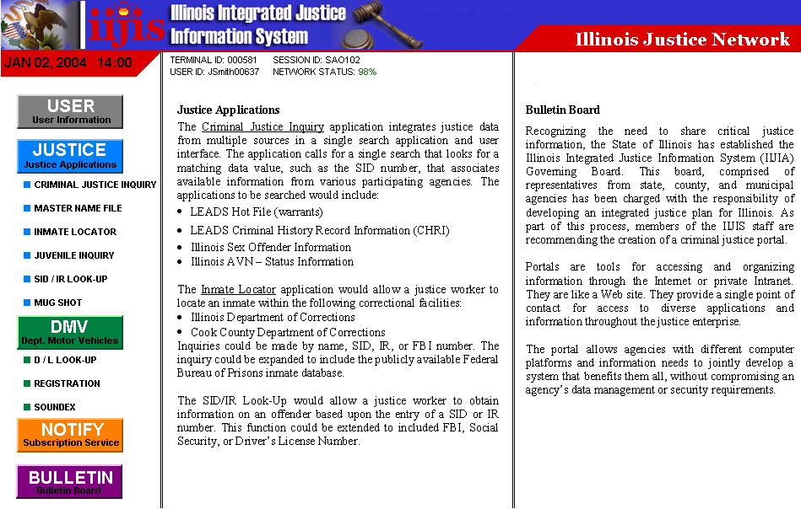
Inmate Locator
The Inmate Locator application would allow a justice worker to locate an inmate at an Illinois correctional facility:
- Illinois Department of Corrections
- Cook County Department of Corrections
- Other County Jails (through AVN)

Mug Shot
The Mug Shot function would allow a justice worker to obtain a digital photo from CHRI or the Secretary of State.

Secretary of State
The Secretary of State application would allow access to the following information:
- Driver’s License Information & Soundex
- Vehicle Registration

Juvenile Inquiry
The Juvenile Inquiry would allow authorized access to the CHRI
juvenile arrest database in order to facilitate station adjustments.

SID/IR Look-Up
The SID/IR Look-Up would allow a justice worker to obtain information on an offender based upon the entry of a SID or IR number. This function could be extended to included FBI, Social Security, or Driver’s License Number.

Master Name File
The Master Name File would allow the user to obtain information based upon a name inquiry. Information to be returned would include: SID, IR, FBI, Social Security, date of birth, address, etc.

Notification Service
The Notification Service would contact the requesting agency each time an inquiry is made about a previously “flagged” offender, or criminal justice client, utilizing the Illinois Justice Network.

Bulletin Board
The Bulletin Board would provide an administrative messaging capability.

County Justice Hub The County Justice Hub would link local jurisdictions to state applications, as well as provide a mechanism for county level integration. The Justice Hub could be used to transfer warrants to LEADS as well as booking, charging, and disposition information to CHRI. The core data gathered at each of these events could be made available, on the County Hub server, to other county level justice agencies facilitating integrated justice.

Counties in Illinois currently have two state-level sources of core (booking) data. The arrest information reported to the State Police and the arrest information reported to AVN. Much of this data is collected electronically via Live Scan and the AVN system.

The County Hub solution could also be a platform for the development of future systems such as standardized police incident reporting, traffic citations, and court case management. These systems would facilitate horizontal integration between justice agencies. For example, police within a county could use the County Justice Hub to exchange incident level data.

Data Warehouse The data warehouse application would require the creation of a
CHRI data warehouse that would be used for ad-hoc queries. The data warehouse would be accessed through a screen on the Justice Portal.

Such an application would be a powerful crime-fighting tool. For example, police receive information that a person wanted for an armed robbery lives on a particular street. The data warehouse could be queried for all past offenders living on that street in an effort to obtain possible addresses.

Wide Area Network The portal, the County Justice Hub, and the data warehouse are dependent on Wide Area Network (WAN) connectivity. Illinois currently operates two statewide network services, the Illinois Century Network and the Illinois Frame Relay Service. Either network could be used to handle justice information in a secure manor.

