Integrated Justice The exchange of information between two or more agencies is known as inter-agency or business-to-business integration. There are generally two types of integration, vertical and horizontal.
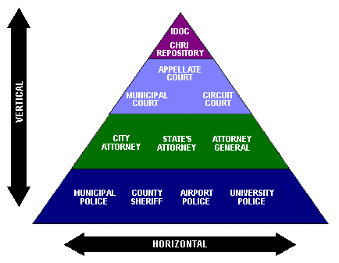

Vertical Integration involves the upward sharing of information between agencies. It is workflow oriented and designed to automate the data flow. An example would be the sharing of information between law enforcement, prosecutors, courts, and corrections.

Horizontal Integration involes data sharing between like agencies.
The process is limited to real-time data queries and access. An example would be the sharing of incident level and arrest information between police agencies to assist in criminal investigations.

Architecture To date, two principle architectures have been used to support integrated justice:
      - A central repository for cross agency information
      - Distributed Systems (data stored locally by each agency)

Central Repository
A central repository utilizes a unified database to collect and store information from multiple agencies. Each component of the criminal justice system enters and retrieves data from the same computer system. Examples include McLean County, Illinois and Harris County, Texas.

The McLean County Integrated Justice Information System (IJIS) utilizes a unified database that begins with the original police report. Information gathered at each stage of the criminal process is additionally entered into the system and made available to authorized users. Information is collected utilizing the following modules:

- Law Enforcement
- Jail Management
- Courts/State’s Attorney
- Probation

The Harris County Justice Information Management System (JIMS)
consists of a unified database with over 5,700 access terminals. The
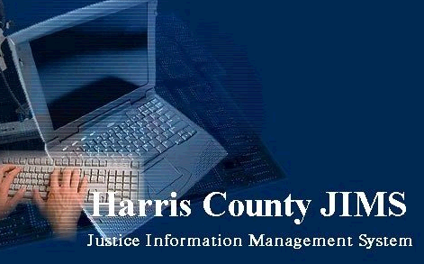
system is designed to provide one-time entry of data and efficient
access to justice information for all agencies that use the system.
Information is collected using the following modules:
- Law Enforcement
- Criminal
- Civil
- Juvenile
- Jury

Distributed Systems
Distributed Systems do not utilize a central repository of data. Rather, each agency maintains its own operational system. Authorized users enter the system and view published data that has been obtained either through direct access to the legacy system or indirect access through an intermediary server. Indirect retrieval is a middleware solution that allows data from one computer system to be moved and adapted for use by another.

Distributed systems are normally dependent on wide-area-network connectivity and utilize Internet technology. They typically use a portal to link end-users to state supported systems, such as criminal history and motor vehicle information. However, they are also being used to provide access to county level data and to facilitate county level integration.

Most jurisdictions have facilitated integrated justice through the establishment of a justice portal. Distributed systems are in use in Washington DC and San Diego County and by a number of states including Colorado, Nebraska, Pennsylvania, and Kentucky, each using a different architecture.
Washington DC The Washington DC Justice Information System (JUSTIS) provides for direct data retrieval from participating agencies. JUSTIS allows its users to share information through a variety of modes: Predefined queries allow participants to access data in other agencies’ systems; information is shared through the publishing of static screens; and searches can seek information across the entire World Wide Web. Only data that each agency has chosen to share is made available. Secured email and notification services are also available.


Core arrest data is also made available to all participants. The Washington DC Police gather core data at the time of arrest, assign a Public Safety Tracking Number, and forward the data directly to the Core Data Transfer Server. This data is then made available to all participating JUSTIS agencies, which have the option of downloading the information into their legacy systems to populate their own databases. Once in an agency’s legacy system, the agency can use the data as necessary, eliminating redundant data entry.

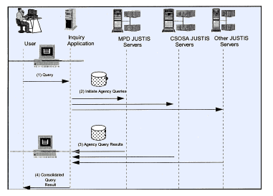
In addition to core data, JUSTIS provides access to a variety of information and services including:
- Arrest Data
- Juvenile Data
- Department of Motor Vehicle Data
- Mug Shots
- Notification Service (flag suspects & wanted persons)
- Public Access (sex offenders, missing and wanted persons etc.)

San Diego The Automated Regional Justice Information System (ARJIS)

connects all criminal justice databases in San Diego County. ARJIS contains data on police incidents, arrests, citations, field interviews, traffic accidents, gangs, and stolen property. The ARJIS Net intranet integrates over 2,500 workstations and printers throughout San Diego County. There are over 10,000 authorized users generating over 35,000 transactions daily.
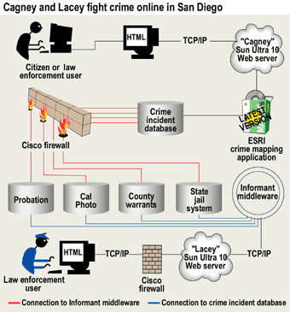
ARJIS is also utilized for tactical analysis, investigations, statistics, and crime analysis. Police officers can additionally request an electronic notification whenever information on a flagged individual, location, or vehicle is obtained. ARJIS also contains a public area where anyone can find statistical crime information, most-wanted lists, and interactive crime maps.

ARJIS runs on a Sun Microsystems Ultra 10 server with a 440-MHz Ultra Sparc processor. ARJIS utilizes INFOTECH, a component of a larger program called the Advance Generation of Interoperability for Law Enforcement (AGILE). The user interface is a commercial off-the-shelf (COTS) Web browser, allowing officers using wireless laptops and hand-held personal data assistants, to query the databases.
The success of ARJIS is based on the “Google for Cops” function, in which a single query accesses all justice databases. Information available from ARJIS includes:
- Booking Photos
- Arrest Warrants
- Officer Notification - Parole, fugitive, sex offender, & gang
- Department of Motor Vehicles
- 911 CAD Data
Colorado The Colorado Integrated Criminal Justice Information System (CICJIS) is a middleware solution in which each agency maintains its own legacy system linked by a central index. Information needed by any agency is automatically routed to the requesting agency according to predetermined business rules. This solution allows Colorado to leverage its investment in existing systems without building an entirely new one.
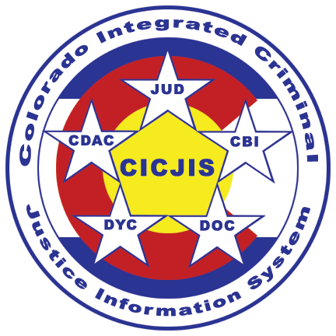

CICJIS creates a virtual database that translates data between systems so users at the receiving agency see information as if they had entered it. CICJIS is designed to handle event-driven transfers, queries between systems, and data extracts for decision support and public access. The system is based on real-time data exchange, which takes data entered by the originating agency and automatically updates the other relevant systems.

The main component of CICJIS is the Central Index, which contains a limited amount of information about each subject. This information is used to determine which agencies have data about a person. A common identifier, know as a SID, is used in the central index as a unique identifier for a subject within CICJIS.

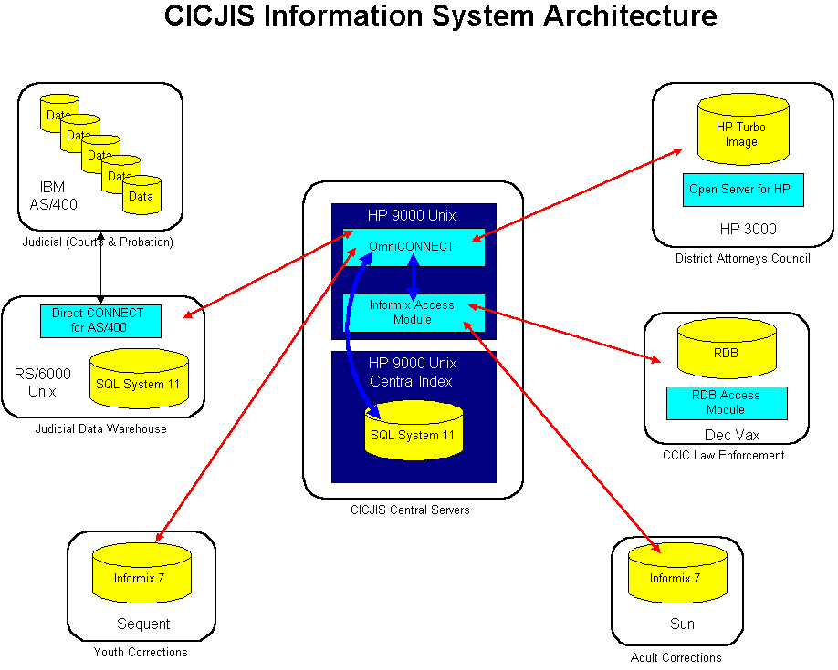

CICJIS uses a private network to transfer data and handle inquiries:

Data Transfers include: court scheduling events, restraining orders, initial case filings, arrests, witness information, amended charges, warrant information, sentencing, and case dispositions.

CICJIS Queries include: driver’s history, minute orders, SID, criminal history, restraining orders, warrants, and financial summaries (fines, fees, and restitution).
Minnesota CriMNet is designed to support the exchange of data across
disparate criminal justice information systems. CriMNet is not one single project, but incorporates many projects that are being developed by criminal justice organizations throughout Minnesota. Integration architecture is driven by local operational needs and uses standards that will support the exchange of data across existing and developing systems.


Participating state, county, and municipal criminal justice agencies are connected to CriMNet through their local Integration Middleware and Web Services Hub. Each local hub contains the business rules and data schemes needed to integrate shared criminal justice data within that jurisdiction. The hub provides the means to share and register information with the Integration Backbone and shared data environment; the interface to local systems; and indexes and pointers to additional data. Agencies have control over their own data and determine how and when that data is made accessible via CriMNet. They also have control over the exchange of data between agencies within their jurisdiction.

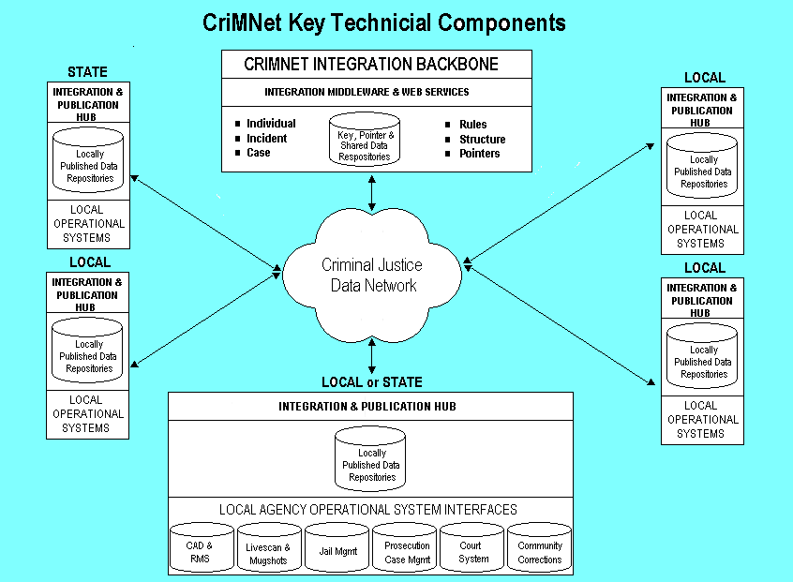
CriMNet provides access to the following information:
- Minnesota Court Information System
- Minnesota Repository of Arrest Photos
- Statewide Supervision System
- Predatory Offender Registry
- Cardhandler/Livescan Project (booking information)
- Victim Information and Notification Everyday (VINE)
- Improved Minnesota Driver’s License Record System Project
- Multiple Jurisdiction Network Organization (data sharing)

NEBRASKA The Nebraska Criminal Justice Information System (NCJIS) is an Internet based system that allows access to a variety of state level criminal justice databases including criminal history, probation, corrections, and sex offender registration.


NCJIS utilizes Internet technology to create a virtual warehouse of
criminal justice information that is accessible via the state network or through a secure Internet connection. Data is either copied to the NCJIS server or directly accessed by means of a centralized index. Data files, however, remain under the control and oversight of the contributing agency.

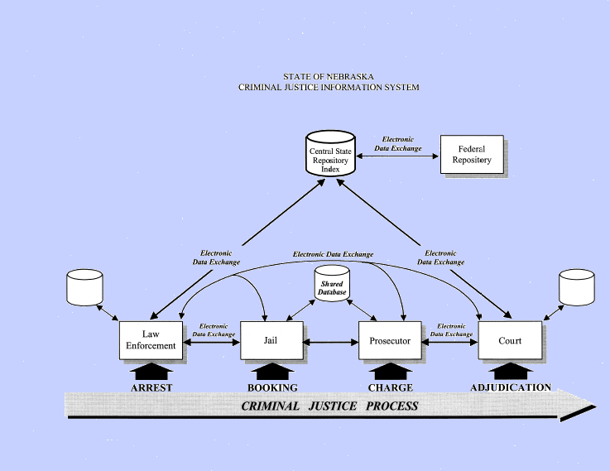
In addition, NCJIS has developed local applications including a standardized law enforcement records management system, a prosecutors case management system, and a jail management system that facilitate the exchange of information between local agencies.

In addition to name-based searches, subject demographics and
other identifiers can also be used to search the data. The following
information is available:
- Criminal History
- Local Jail Bookings
- Orders of Protection
- Sex Offender Registration
- Drivers License & Vehicle Registration
- Mug shot
- Probation

Pennsylvania The Pennsylvania Justice Network (JNET) provides a common on-line environment whereby authorized users can access justice information from participating agencies. JNET uses Internet technology to link diverse hardware and software under a common, web-browser interface. A Hub Server provides a shared platform for centralized applications and inter-agency communication, while firewalls protect agency networks and systems from unauthorized intrusion.


JNET also serves as a platform for knowledge sharing among state and local justice agencies. Access to JNET not only allows participants to search state-level justice agencies, but also provides county justice practitioners with a single data integration platform, the County Justice Hub, to support local information sharing needs.

The County Justice Hub solution utilizes the JNET Messaging Infrastructure to enable the integration of separate computer systems and allows those computers to communicate by sending messages to each other. The Case File Transfer component enables the transfer of pertinent data from one agency to another as an offender progresses through the justice system.
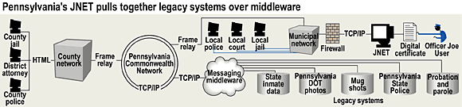
The Justice Hub design enables justice practitioners to perform the following functions in a real-time manner:
- Obtain Criminal History Records
- Obtain Juvenile Information
- Obtain Driver’s License Photos
- Locate Inmates
- Query justice data stored in participating agency systems
- Receive a notification of a change in case status
- Share photographs, fingerprints, and documents
- Exchange criminal justice data with other agencies

Kentucky The Kentucky Unified Criminal Justice Information System (UCJIS) utilizes a hybrid architecture. The two components of this
design include a central system that controls the flow of information from information from one system to another and a central repository for

cross agency information.

Each agency maintains its own operational systems, but also receives critical information from other agencies and can query a central repository. This approach allows agencies to maintain their individual data, and share information with each other as well as a central database. The central repository provides a resource for inquiry/reporting and serves as an alternate source of data, from which interested agencies can retrieve information.

Document Exchange Architecture is the primary method for the controlled exchange of information between agencies. While the Document Exchange solution can satisfy data entry and standard data viewing needs, it does not provide access to the variety of data needed to answer ad-hoc queries or report generation. Therefore, a separate data storage component is provided which can efficiently receive data from the participating systems for storage. Data integration middleware is used to extract data from operational systems on a timely basis and store data in the repository.

The UCJIS Document Exchange Information Hub (Store and Forward) manages the receipt and distribution of documents from the provider of the information to all agencies that require it. Functionally, this server acts as a switch routing requests and responses (documents) based on business rules.

KANSAS
The Kansas Criminal Justice Information System (KCJIS) is a
statewide, integrated justice network that became operational in
1998. It may be accessed by criminal justice users either via the

state intranet or the Internet. Approximately750 criminal justice
agencies are using the system.

The main components of the KCJIS include a statewide network,
a criminal history repository, an incident based crime reporting
system, AFIS, and email.

The agencies involved in KCJIS include:
- State Highway Patrol
- Sheriff's Offices and Police Departments
- 105 Courts in 31 Judicial Districts
- County and District Attorneys
- Department of Corrections
- Department of Motor Vehicles
- Kansas Bureau of Investigation
- Juvenile Justice Authority
Agency environments are the same as they were before the
development of KCJIS. The majority of the work has been
integrating existing applications with middleware and writing
stored procedures for the Omni CONNECT and SQL Server
databases. This was primarily done through the Open Client
Module (OCM). The central data warehouse is accessed via
point-to-point network (KANWIN) and via Internet.

The KCJIS utilizes the Kansas TCP/IP telecommunications
network to provide delivery of information to each of the 105
Kansas counties.

The KCJIS network provides access to the following information:
- Criminal History
- Missing Persons
- Wanted Persons
- Registered Offenders
- Drivers License and Vehicle Registration

Summary What should IIJIS look like?
- A central repository for all Illinois justice data?
- Regional repositories for Illinois justice data?
- A distributed system connecting county and local systems?

What is role of state?
- To build county and local integrated justice systems?
- To build state level systems only?
- To build hybrid systems?
- Education and grants only?

